Deep Learning Lab Assignment-3

Name: Saketh Garuda

ID: 16

## Introduction:

This lab assignment helps in learning about the working of tensor flow and implementation of text classification with CNN, RNN and LSTM model using python. Visualization charts and graphs are created and displayed in tensor board.

## Objective:

The main objective for this lab assignment is to know the

* Text classification and analysis using CNN, RNN and LSTM methods
* Visualizing graphs in tensorboard
* Providing justification for accuracy analysis between the models.

## Configuration:

* PyCharm IDE
* Python 3.6.4
* TensorFlow

## Approaches/Methods:

The CNN, RNN and LSTM models are implemented using python libraries 3.6. Tensorflow and visualization graphs are created using tensor board.

## Workflow:

The workflow for the entire model is as follows,

* Loading dataset using import library modules
* Processing data
* Performing CNN, RNN and LSTM operations on data
* Calculating loss and predicting accuracy
* Using session graph for creating visualization graphs in tensorboard.

## Dataset:

Consumer complaints dataset is used in this exercise, which consists of 11 classes. LSTM, CNN and RNN models are used to preprocess and train the dataset.

## Parameters:

The parameters to be considered while constructing the model are,

* Number of epochs
* Batch Size
* Embedding dimensions
* Size of filter
* Probability check
* Dropout probability

## Evaluation and Discussion:

## Text Classification using CNN:

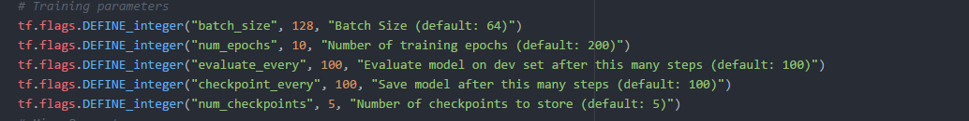

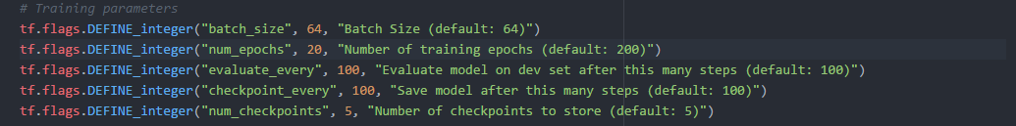

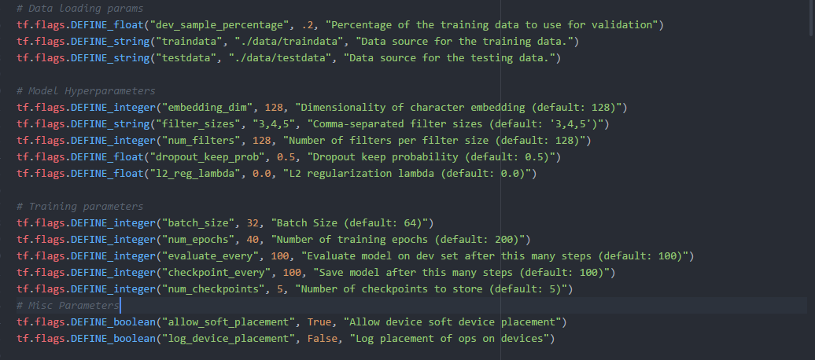

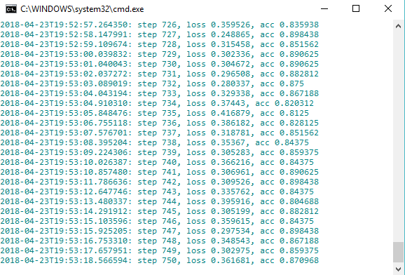

## Text Classification using RNN:

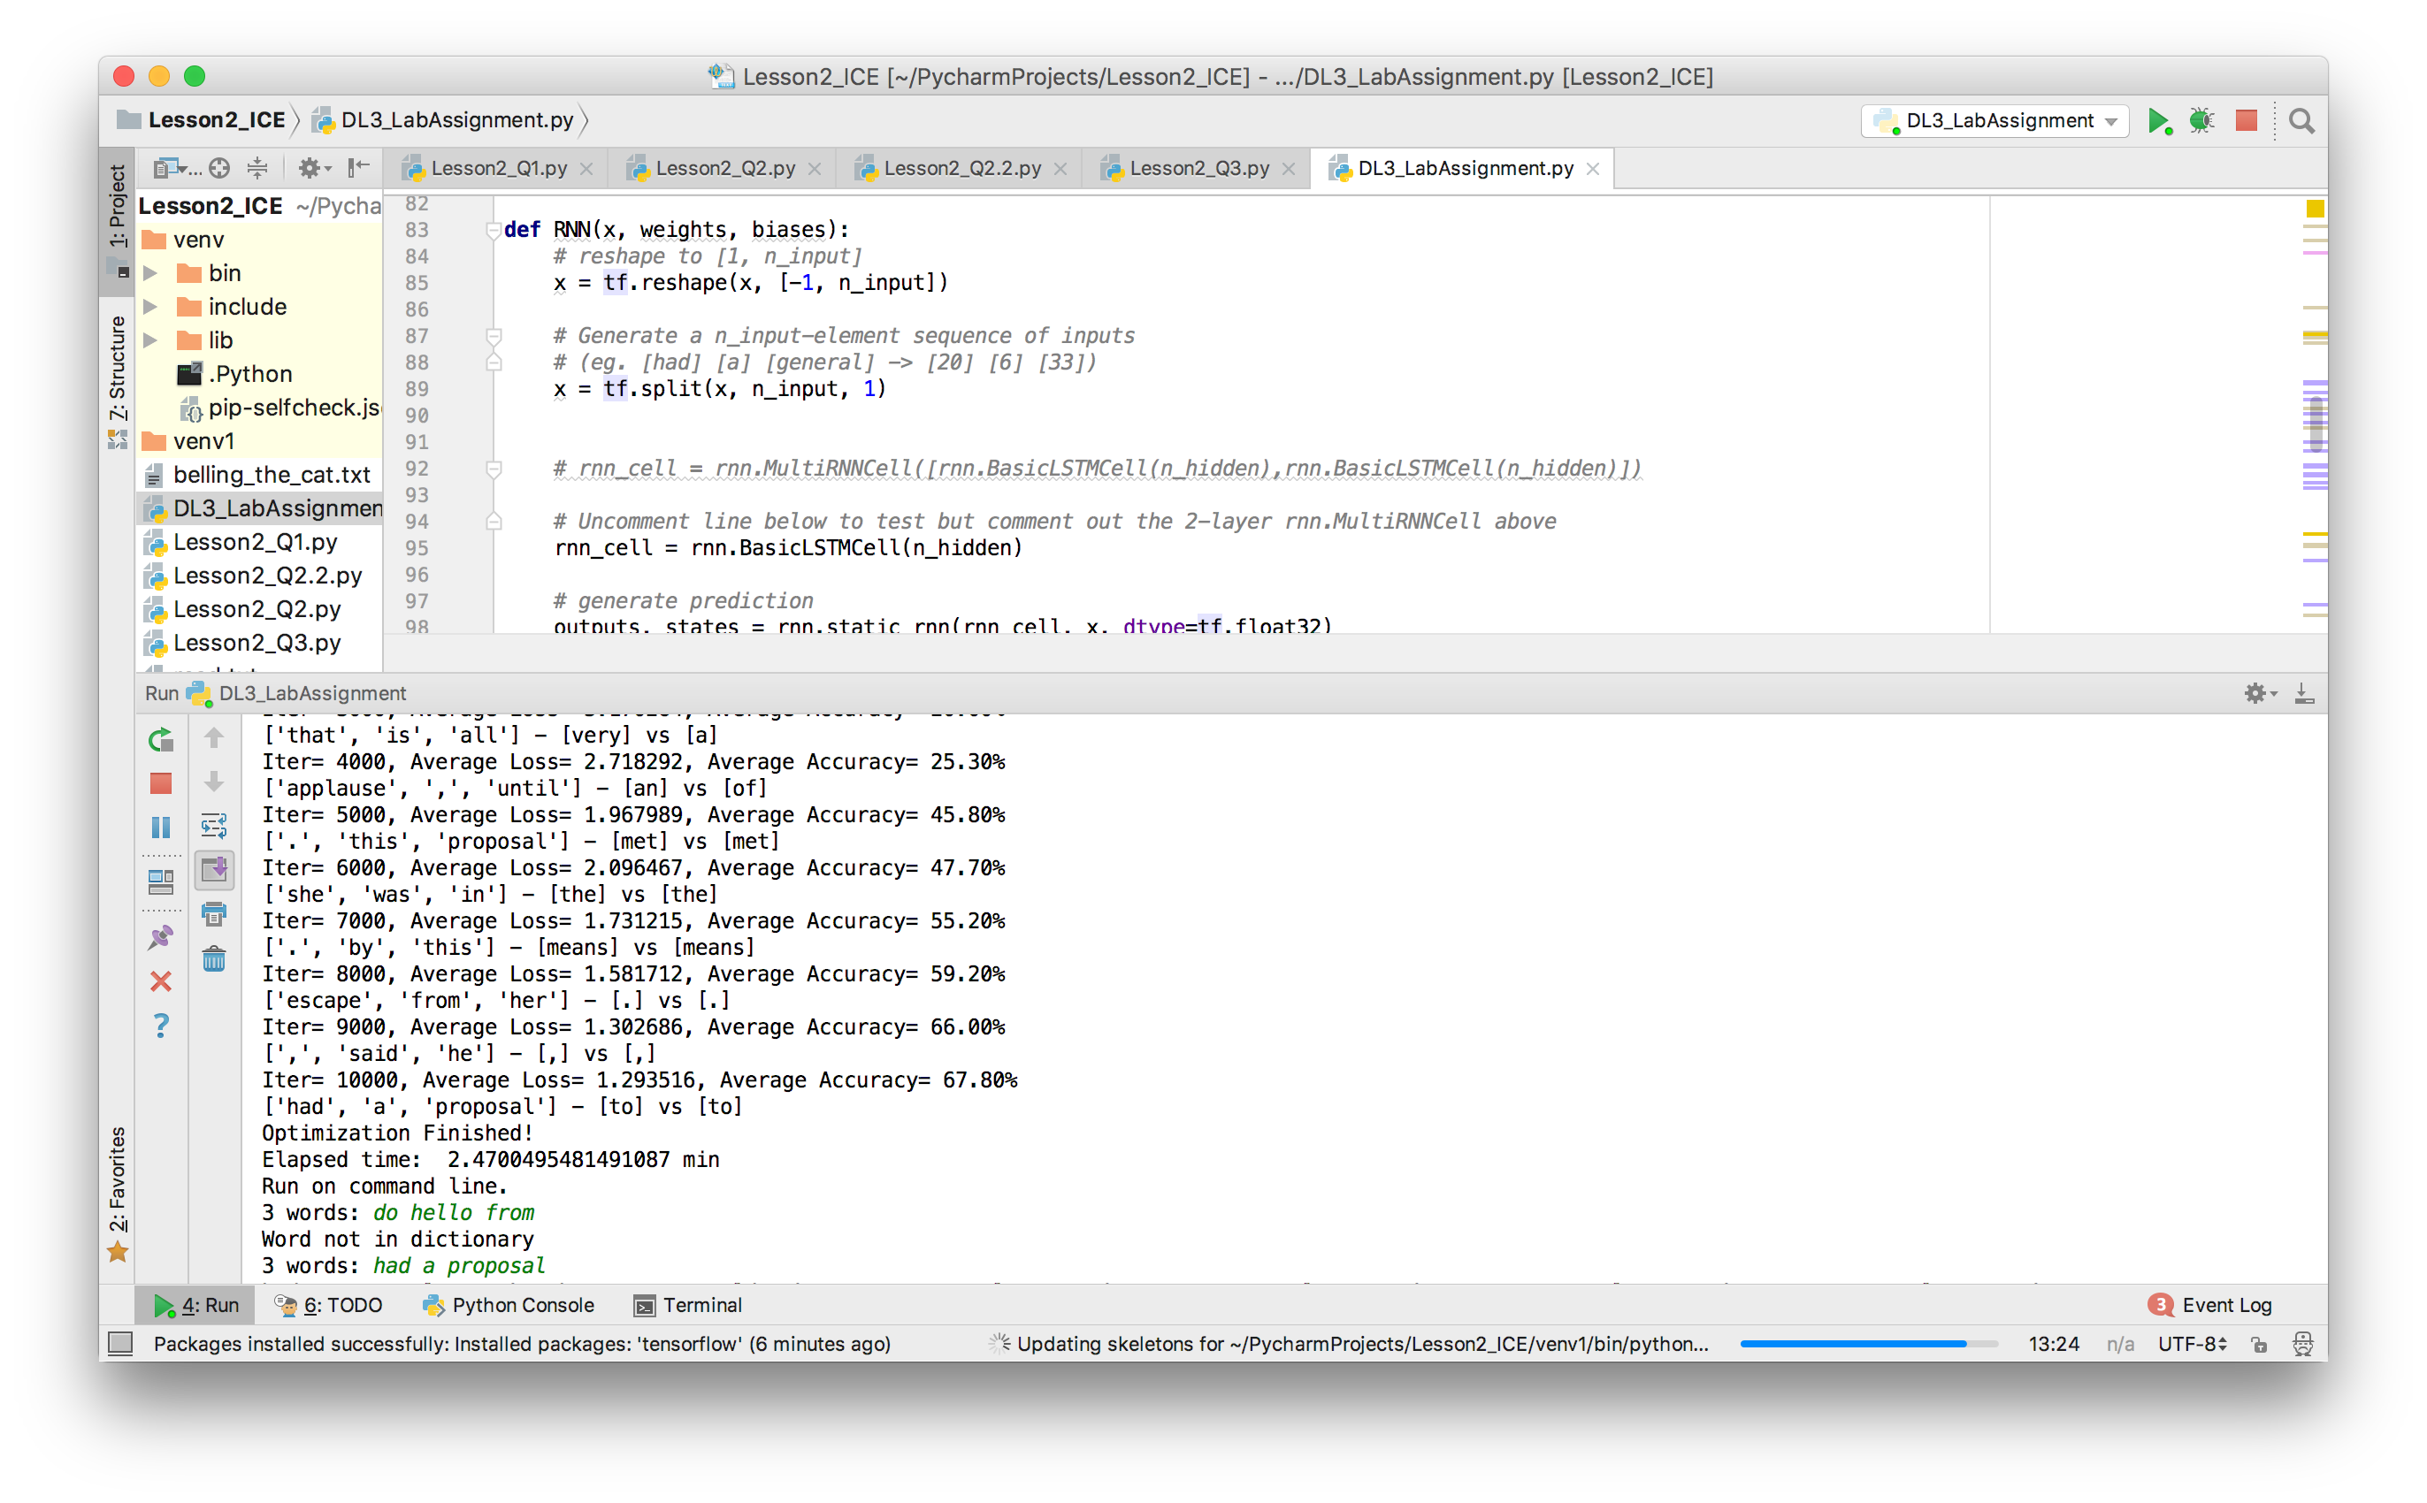

## Text Classification using LSTM:

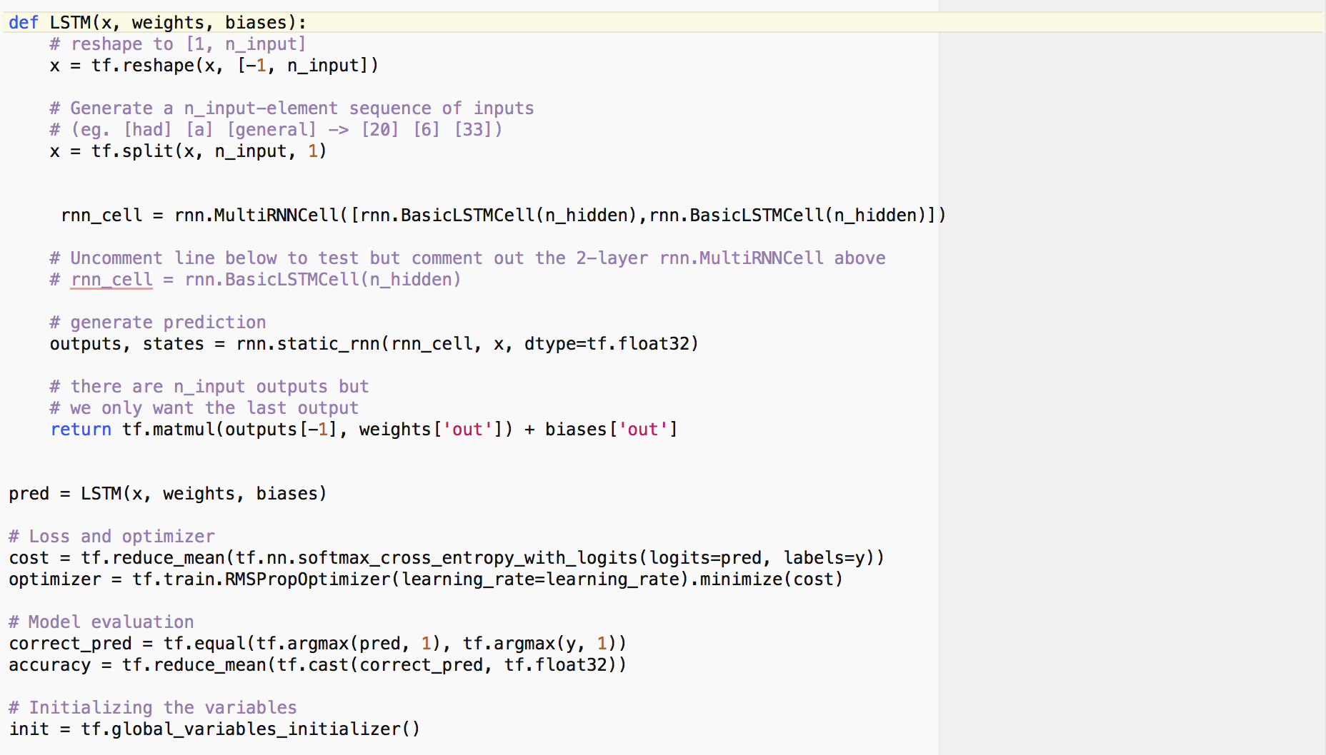

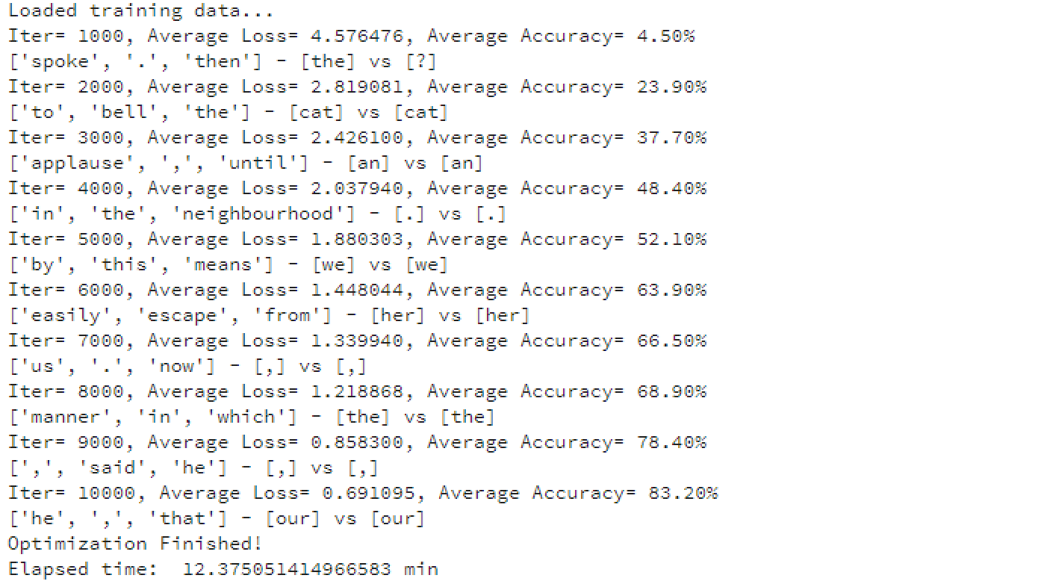

The results between the model i.e. CNN, RNN and LSTM are compared and analyzed on the given data set. RNN and LSTM model are comparatively better in producing accurate results than CNN model for the dataset. LSTM is better over RNN since it LSTM cell can maintain memory for longer periods of time than RNN. Longer term dependencies is an advantage of LSTM which has a good chance of increasing accuracy of data.

## References:

* <https://www.tensorflow.org/tutorials/wide>
* <https://www.kaggle.com/cfpb/us-consumer-finance-complaints>
* <http://colah.github.io/posts/2015-08-Understanding-LSTMs/>